6 Using a Neural Network to Fit the Data (2) & Exam Review
Recap: The Learning Process
Forward pass
Given input data and initial values for the weights, the model is fed input data
Backward pass
A measure of the error is evaluated by comparing the outputs to the ground truth
The gradient of the error with respect to the parameters is computed using the chain rule
Optimize the parameter of the model: the value of the weights is then updated in the direction that leads to a decrease in the error.
The procedure is repeated until the error falls below an acceptable level.
Neural Network: Forward Pass
- Step 1: Model initialization: Randomly set initialized neural network
- Step 2: Feed forward: The model is fed input data
Neural Network: Backward Pass
- Step 3: Calculate the error: How far is your model output from the actual value.
- Step 4: Compute gradient of the error: apply the chain rule to compute gradient with respect to the parameters
- Step 5: Update the parameters: Update the parameters (weights and biases) until the error becomes minimum.
Overview
A Multi-Layer Neural Network
Cost-benefit Analysis
Steps to Build A Multi-Layer Neural Network
Step 1: Kicked Vehicle Data
Steps to build a decision tree model
Step 2: Data Preprocessing
Dummy coding
Dummy coding: convert categorical variables into numeric format
Create dummy variables to replace the original categorical variable
Dummy coding for a binary variable: gender
Data Transformation
Standardization (Z-score standardization)
Step 3: Build a Neural Network on Training Data
Step 3: A Multi-Layer Neural Network
Build a model with nn.Sequential
Tensors, Tensor Dataset, and Data Loader
TensorDataset: wraps tensors to form a tensor dataset. It stores the samples and their corresponding labels.
DataLoarder: wraps an iterable around the Dataset to enable easy access to the samples.
◦ Training with minibatches: The job of a data loader is to sample minibatches from a dataset, giving us the flexibility to choose from different sampling strategies.
Batch size: batch size is a hyperparameter that defines the number of samples (data points) to work through before updating the internal model parameters
Epoch: the number of epochs is a hyperparameter that defines the number times that the learning algorithm will work through the entire training dataset
Batch size
B × C × H × W
The reason we want to do this batching is multifaceted
- Less memory usage (compare to loading the whole data set)
- GPUs are highly parallelized
- Statistical information from the entire batch
- Define a complete training loop
Step 4: Evaluate Neural Network Model Performance
Overall model performance comparison
Accuracy
Compare performances on each class
F-measure: single metrics combines precision and recall and
measures the overall performance on each class
Precision: confidence/effectiveness of predictions
Recall: ability of identifying instances belonging to a class
Step 4: Evaluate Neural Network Model Performance: Cost-benefit analysis

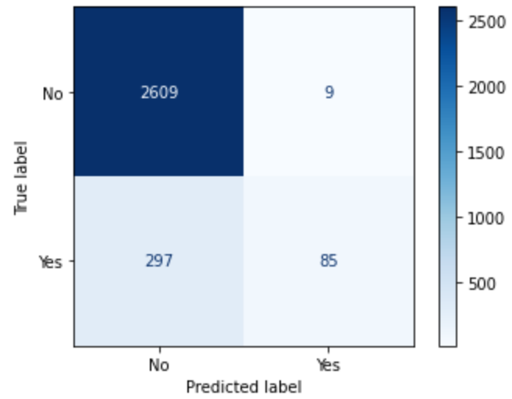

Assume the following costs / benefits:
• Costofbuyingabadcar:$2000
• Profitofpurchasingagoodcar:$300
• Opportunitycostofagoodcarthatis missed: $300
What is the total net benefit/cost of two models?
Step 4: Evaluate Neural Network Model Performance: Cost-benefit analysis


Assume the following costs / benefits:
• Costofbuyingabadcar:$2000
• Profitofpurchasingagoodcar:$300
• Opportunitycostofagoodcarthatis missed: $300
Decision Tree model:
- Cost: 297 (FP)* 2000
- Profit: 2609 (TP) * 300
- Opportunity cost: 9 (FN)* 300
- Profit – Cost - Opportunity cost: 186,000

